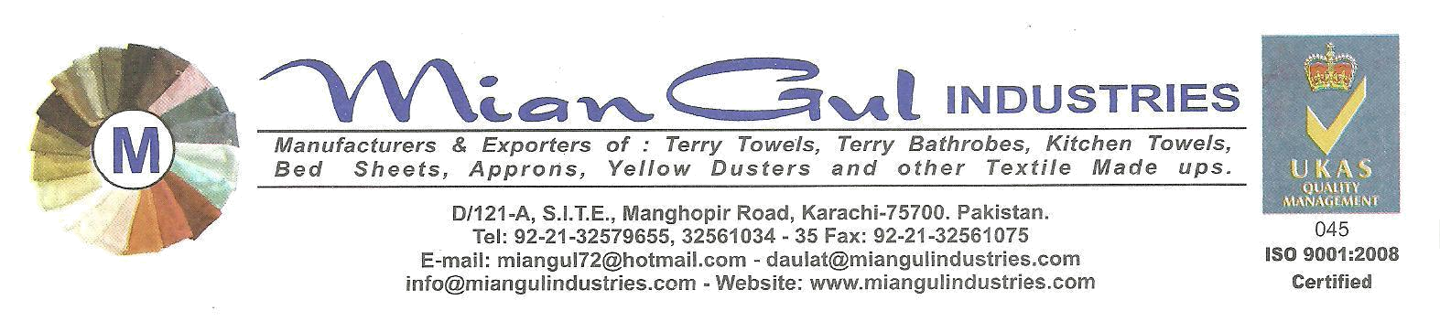
comPANY PROFILE

COMPANY NAME : MIANGUL INDUSTRIES
ADDRESS : D/121-A, S.I.T.E. MANGHOPIR ROAD,
KARACHI-75700, PAKISTAN.

TELEPHONES : +92.21.32579655, 32550406
TELEFAX : +92.21.32561075,
E-MAIL ADDRESS : miangul72@hotmail.com,
info@miangulindustries.com
WEBSITE: : www.miangulindustries.com

CONTACT PERSON DAULAT SHAH, CELL# 92.333.2125377

YEAR OF ESTABLISHMENT : 1982

FACTORY COVERED AREA : 50000 SQ. FT. (4 FLOOR)

BUSINESS CLASS : MANUFACTURER AND EXPORTER

NO. OF EMPLOYEES : 40 PERSONS PAY ROLL AND
150 CONTRACT STAFF

CERTIFICATION : “WRAP”, ISO 9001-2008 AND F.L.A.

MEMBERSHIPS : KARACHI CHAMBER OF COMMERCE AND INDUSTRY
TOWELS MANUFACTURERS ASSOCIATION OF PAKISTAN
S.I.T.E. ASSOCIATION OF INDUSTRIES, KARACHI. .

MAIN ITEMS OF BUSINESS : WOVEN AND KNITTED ALL KIND OF FASHION APPAREL GARMENTS.
TERRY TOWELS, TOWELLING FABRIC, KITCHEN TOWELS, FITTED SHEET (TERRY / JERSEY),

PRODUCTION CAPICITY WOVEN/ 125,000 PCS PER MONTH
KNITS GARMENTS: 100,000 PCS PER MONTH
PRODUCTION CAPACITY : 200,000 LBS PER MONTH (TOWELS $ HOMEXTILES)

PAGE-2

MAIN MARKET OF EXPORTS: U.S.A. U.K. GREECE, SWEDEN, AUSTRALIA, CHILE, U.A.E., FINLAND, JORDAN, MALTA, FRANCE AND OTHER PART OF THE WORLD.

MAIN CUSTOMERS : ARMOUTH INTERNATIONAL INC.USA
DPAM, FRANCE
AMERICAN TEXTILE INC. USA
KOMAL TRADING, USA
ARGEE AMERICAN INC. USA
SINDRELLA DISTRIBUTORS INC.USA
NAYHA TEXTILE, CANADA
BABY PHAT, USA.
EVERLAST, USA
NEW YORK APPAREL, INC. USA
DELTA UNIFORM INC. USA
LIFE IN, USA
K-MART, USA
BOB BARKER INC. USA

MACHINERY DETAIL : INDUSTRIAL MACHINERY DETAILS:
12 NOS. SHUTTLELESS LOOMS OF
TERRY TOWELS & TERRY FABRIC
01 NO. DIESEL GENERATOR – 100 KV
01 NO. BALE PRESS MACHINE

STITCHING MACHINERY DETAILS
150 NO. SINGLE NEEDLE MACHINE
20 NO. SAFETY MACHINE
10 NOS. 4 THREAD SAFETY MACHINE
15 FLAT LOCK STITCHING MACHINE
06 NOS. 2 NEEDLE STITCHING
02 NOS. KANSAI MACHINE\
02 NOS. BATAK MACHINE
02 NOS. KAJ MACHINE
02 NOS. BUTTON MACHINE
02 NOS. CUTTING MACHINE AND ALL SPECIAL MACHINES
02 NOS. FEDO MACHINE
02 NOS. BOILERS WITH 10 PRESS

BANKER : HABIB METROPOLITAN BANK LTD.

